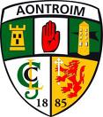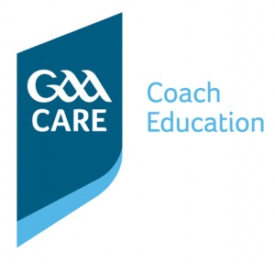

Award 1 Youth/Adult – Level 1 Youth/Adult

Course Outline
Aimed at: Coaches of Youth & Adult Teams (U13 and over)
Entry Requirements: Foundation Level / Foundation Award Course. Course Candidates will be 18 years or over. Candidates will be asked to abide by the GAA Code of Best Practice in Youth Sport
Duration: 28 Hours
Course Fee: £80

Philosophy
The Award 1 Coach Education course is the second award on the coaching pathway of Gaelic games. The course is aimed at coaches that have progressed through the Foundation Award and have experience as a Coach.
The course aims to provide Coaches with the Information and with the Comprehension and Application abilities to know HOW to develop players’ capacities.
The course aims to provide Coaches with the ability to introduce participants to sport in a safe, enjoyable and progressive way. Coaches will develop an all round ability which may lead to further development at a latter stage.
The course will focus on the Practical Application of coaching skills relating to the 3T’s and the 3P’s. This will be achieved through Demonstrative Sessions taken by the Tutor and followed by the Course Attendees taking their fellow participants for application of the demonstrated coaching techniques.

The Aim of the Course is to:
- Provide Coaches with the ability to introduce participants to sport in a safe, enjoyable and progressive way
- Develop Coaching Capacities in the six areas of the OTú Model (The 3Ts and the 3Ps)
- Pride Coaches with the ability to structure a training programme to achieve specific objectives over a season.

Objectives
The coaches will be able to:
- Develop the Techniques of Hurling/Football to an advanced level
- Develop Tactical Prowess and Team Play to improve Decision Making and Team Cohesion
- Develop the Physical Fitness of their Players
- Provide Players with the Skills to Develop their Confidence and Optimise Performance
- Assess the Development of Players and Provide Feedback to Improve Performance
The Award 1 course has been reformatted to take account of the different playing capacities that exist between Children (up to 12 years), Youths (age 13 – 18) and Adults (age 19+) and the competencies that a coach is required to display when working with each of the playing populations. Therefore coaches can specialise in coaching the particular players that they are involved in.
The Award 1 course is 21 hours in duration and encompasses modules in:
- Role of the Coach
- Technical Proficiency
- Tactical Prowess
- Team Play
- Physical Fitness
- Playing Facts
- Psychological Focus
- Communication
- Lifestyle
- Rules

